**Materials:**

Print half as many copies of “GraphPaperMazeBlanks,” as there are students and cut them out.

**Lesson Plan:**

First, go over 2 important definitions:

Algorithm: A list of steps that you can follow to finish a task

Program: An algorithm that has been coded into something that can be run by a machine

Draw a 4x4 square graph on the board. We are going to guide each other to solve a maze on 4x4 graphs. First, fill in the same squares pictured below. Tell students we always start in the top left corner of the graph and aim for the bottom right. Ask for step-by-step instructions to solve this maze.

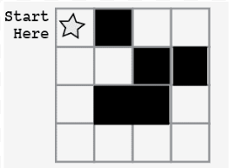

Instructions should be:

* Move down
* Move down
* Move down
* Move to the right
* Move to the right
* Move to the right

Then, introduce a code to make it quicker and easier to give directions:



Rewrite the previous directions with these symbols.

Next, pass out the blank mazes(3 per student), and 1 blank sheet of paper per student. Instruct students to draw a maze and write the code to solve it. Then, have them switch with a neighbor and use the neighbor’s code to solve the maze. Repeat 2 more times.